API Endpoints List :  
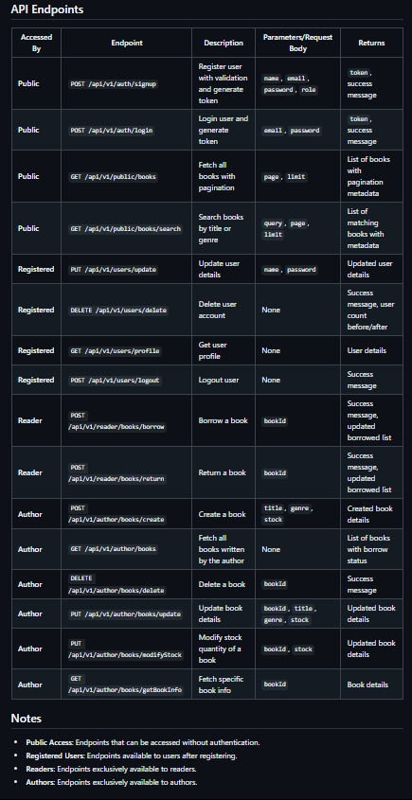

Below are the screenshots of testing those endpoints : 👇

API Endpoint: **POST /api/v1/auth/signup** (Registration of User)

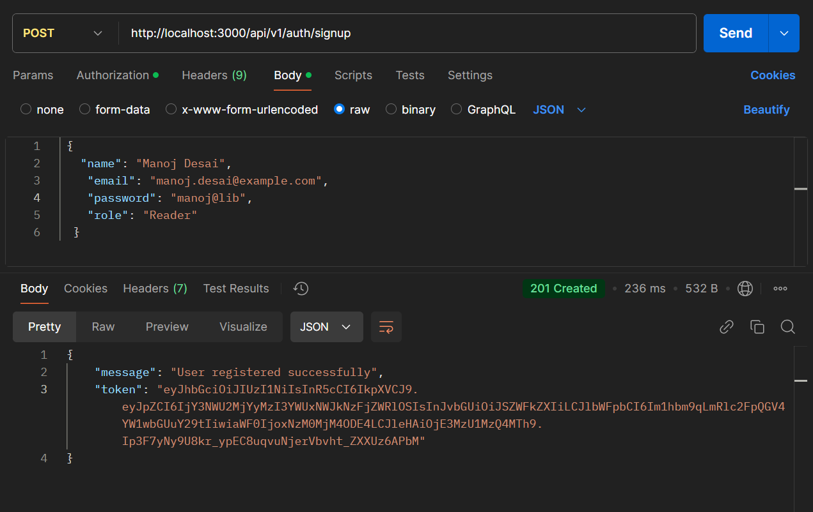

User login

API Endpoint: **POST /api/v1/auth/login**

If user is already logged in

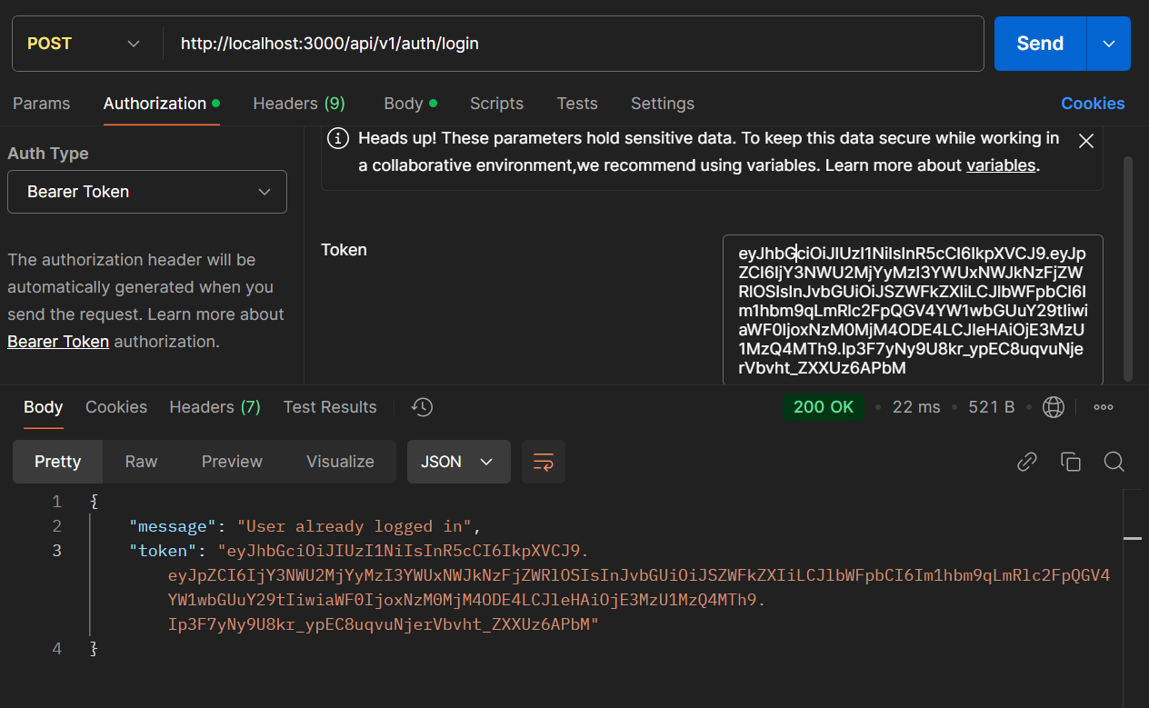

Else login in with correct credentials give you a new generated token

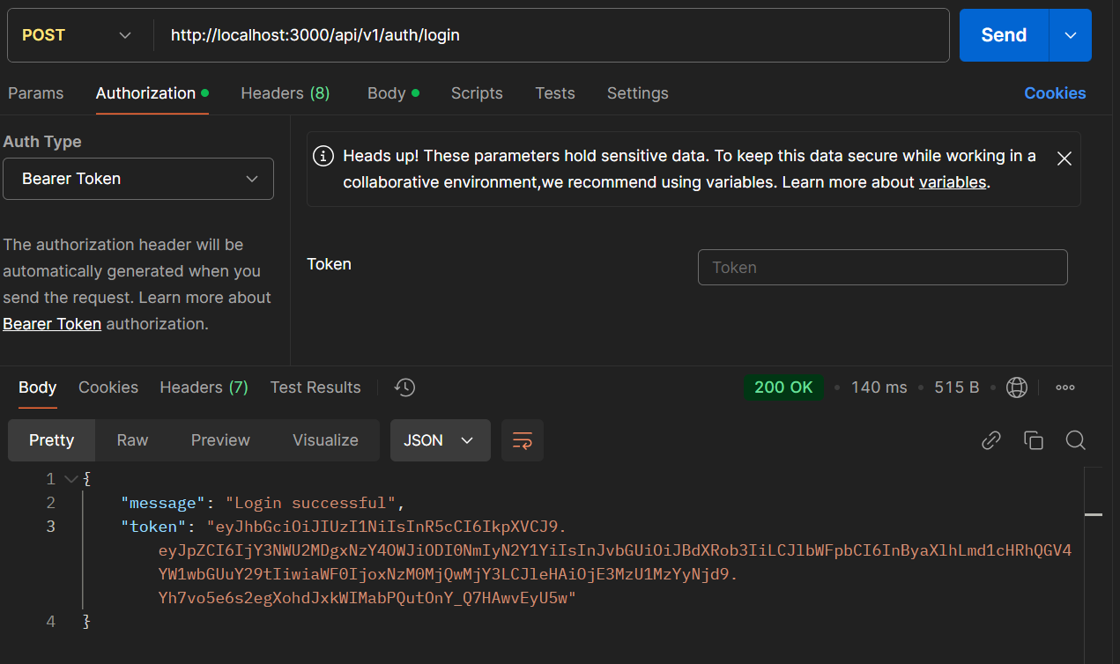

Updating user creds:

API Endpoint: **PUT /api/v1/users/update**

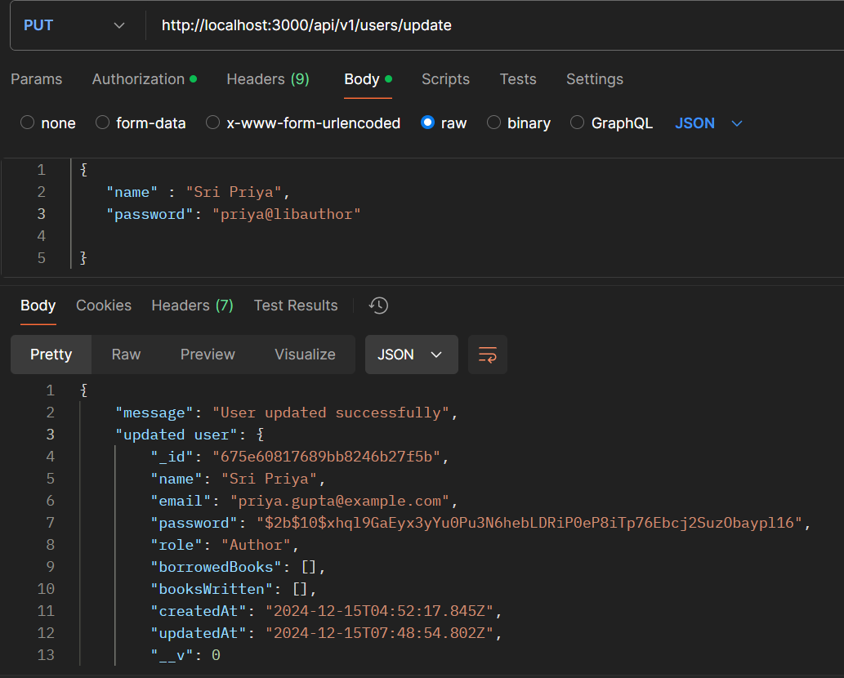

Deleting user while having the authentication token

API Endpoint: **DELETE /api/v1/users/delete**

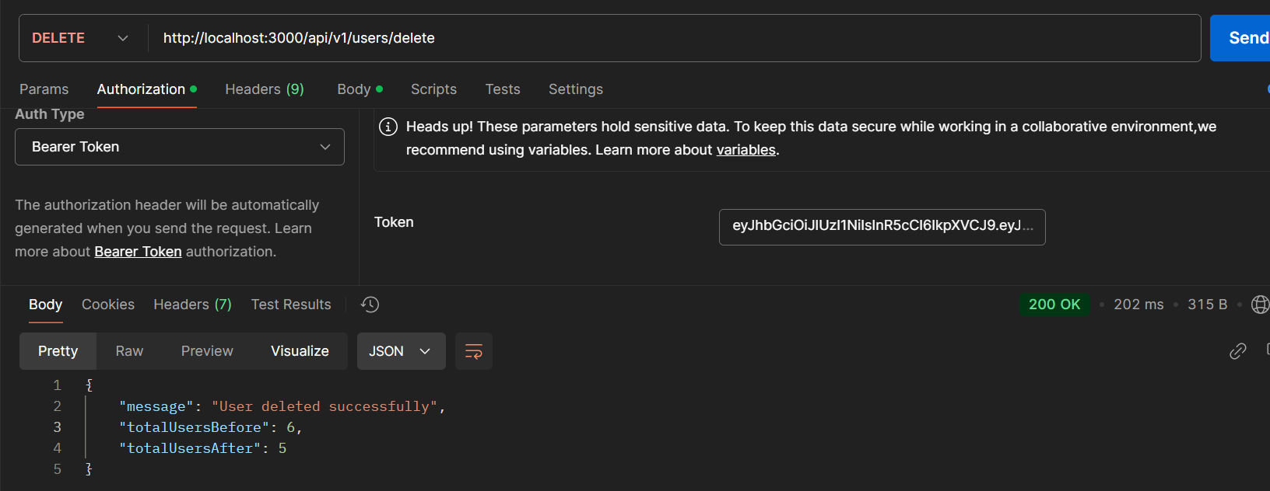

User profile view :

API Endpoint: **GET /api/v1/users/profile**

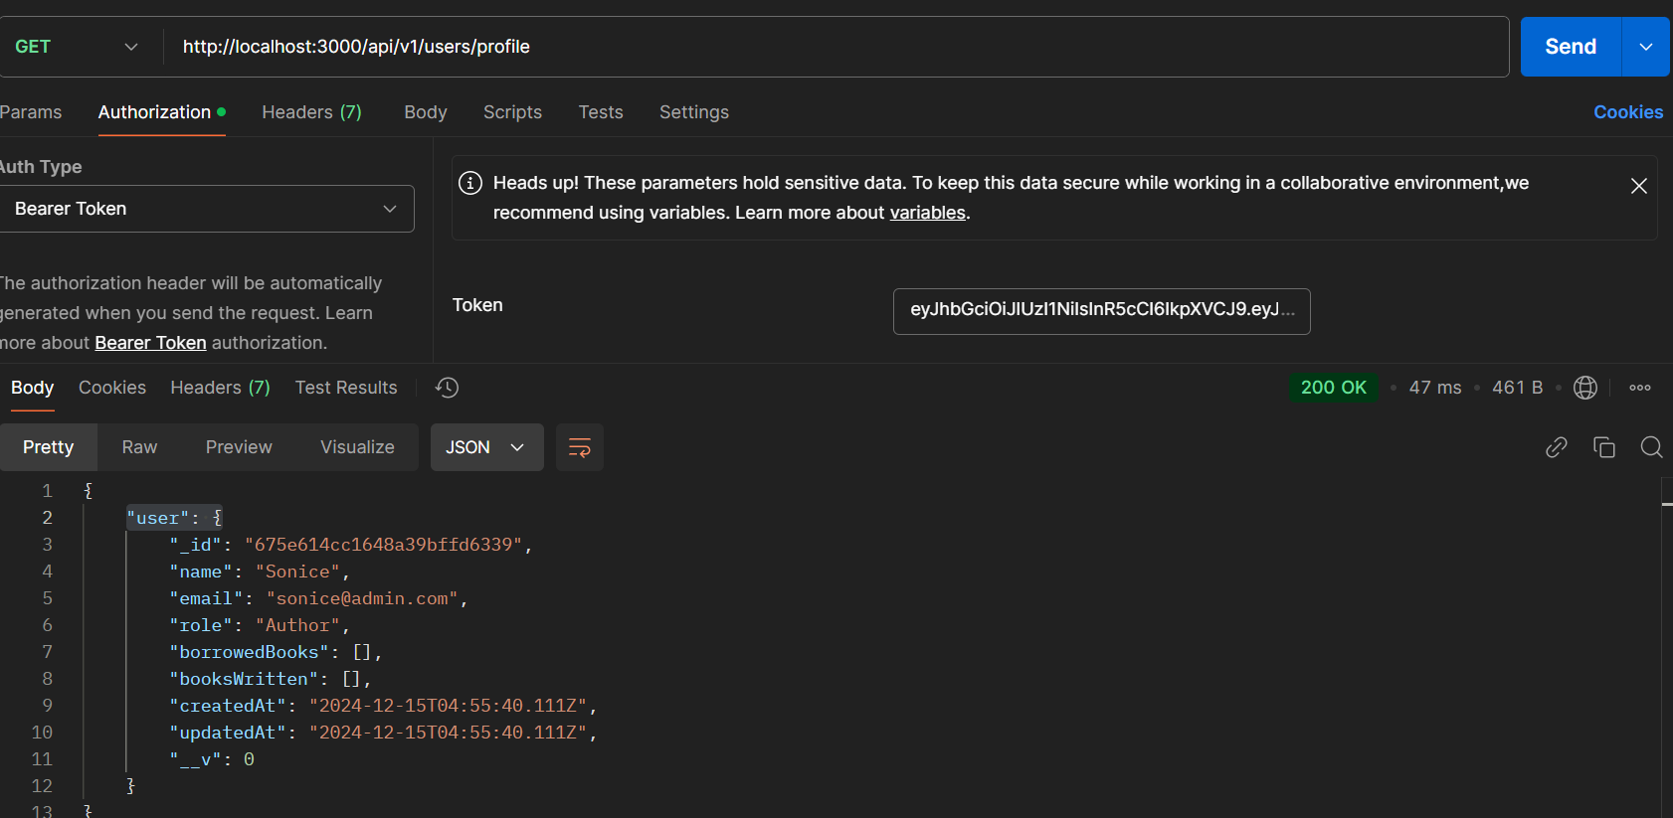

Author only creating a book:

Example 1 : Example2:

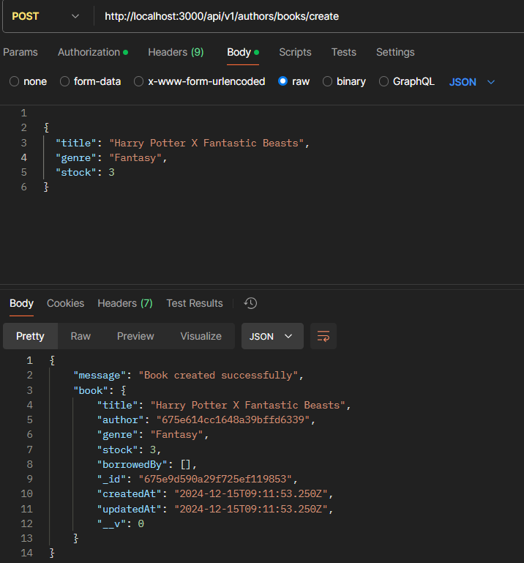 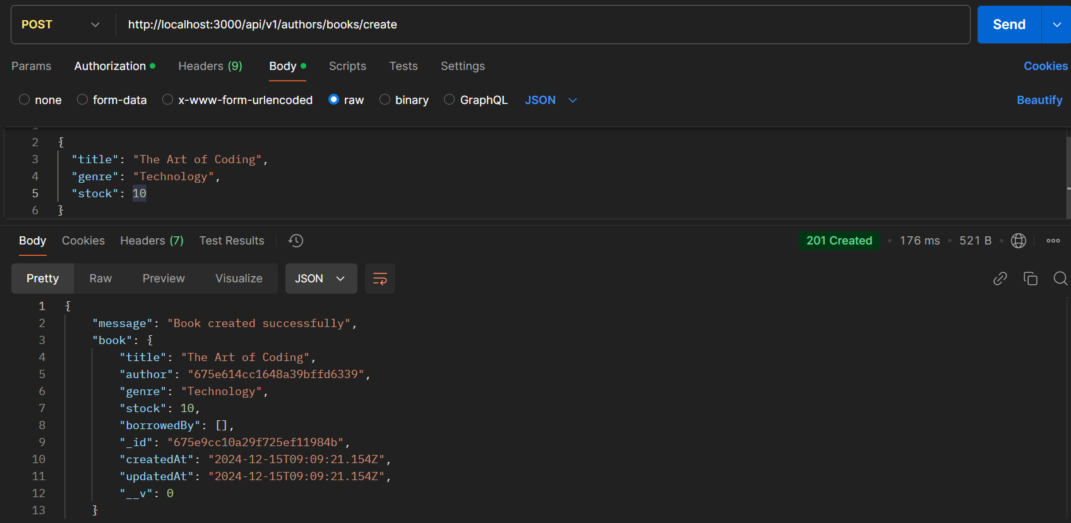

Author viewing multiple his own books:

API Endpoint : **GET /api/v1/author/books**  
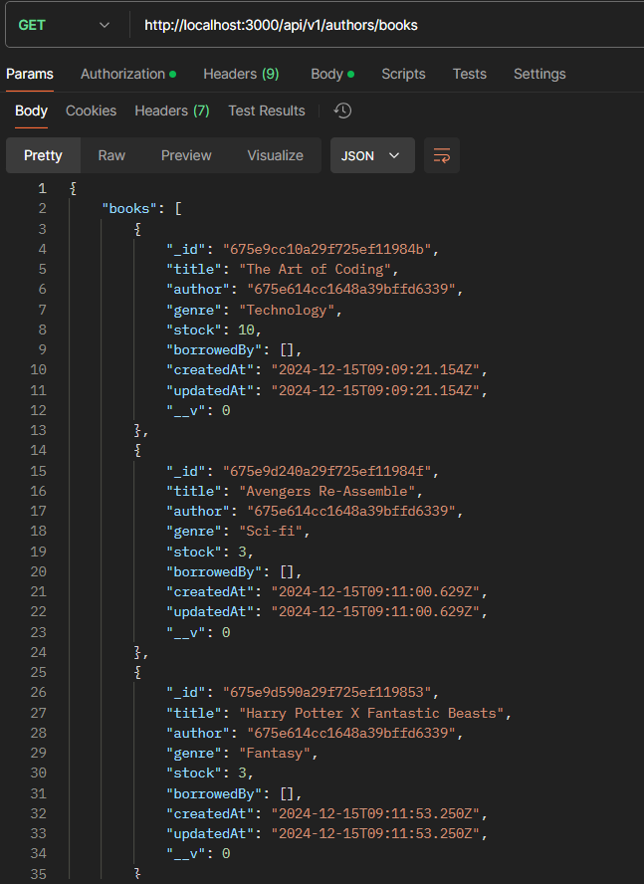

Author Updating a book :

API Endpoint: **PUT /api/v1/author/books/update**

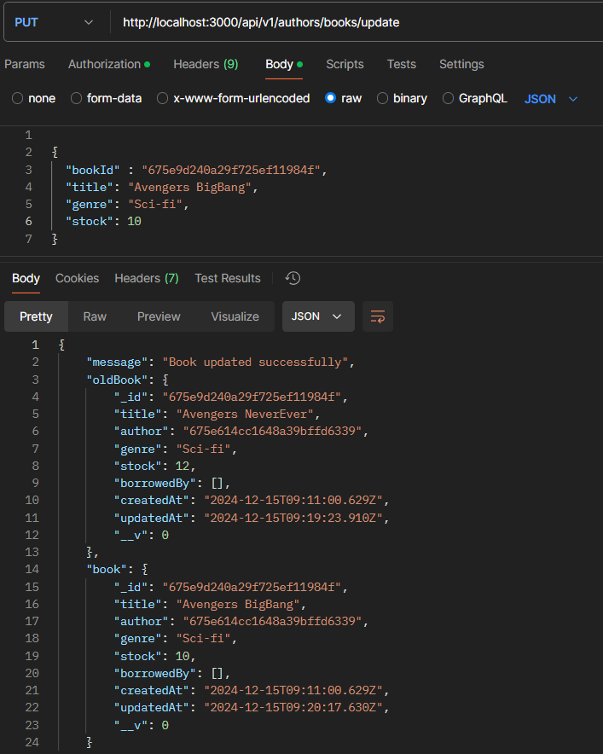

Delete a book:

API Endpoint: **DELETE /api/v1/author/books/delete**

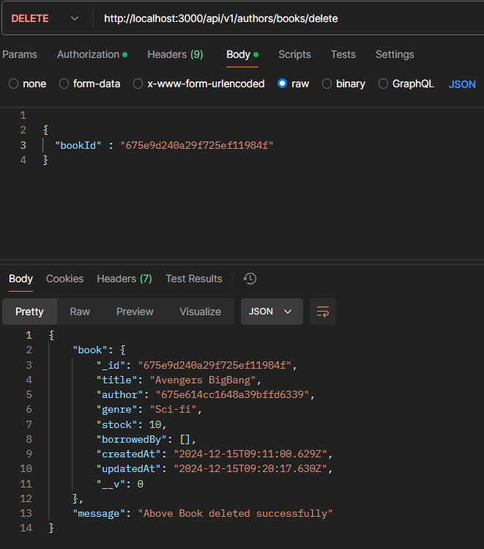

Author - Modifying the stock only :

API Endpoint : **PUT /api/v1/author/books/modifyStock**

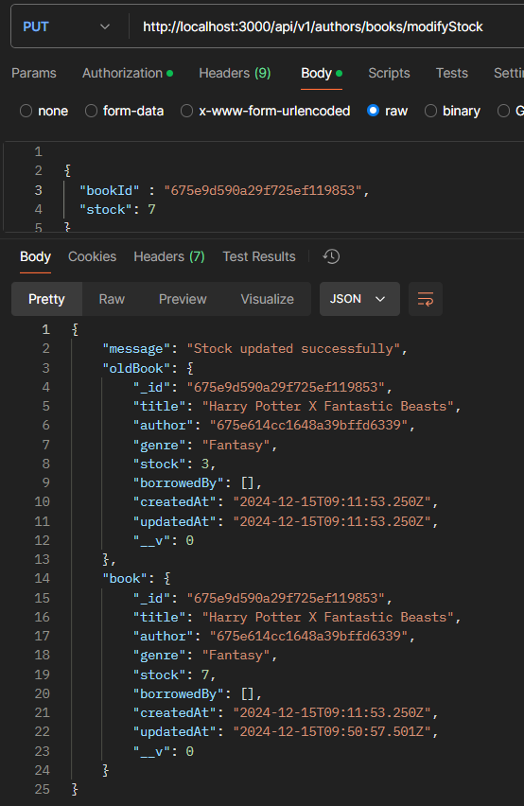

READER - Borrowing book : Authors POV

API Endpoint: **POST /api/v1/reader/books/borrow**

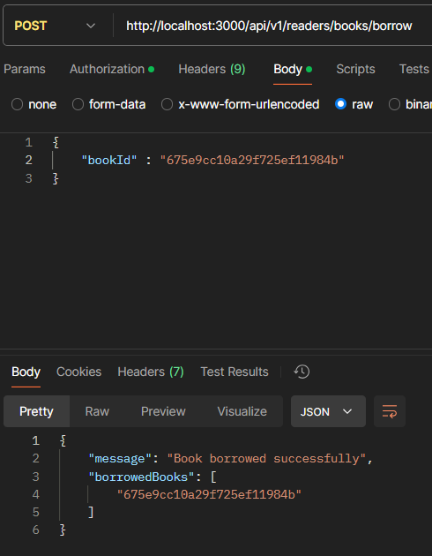 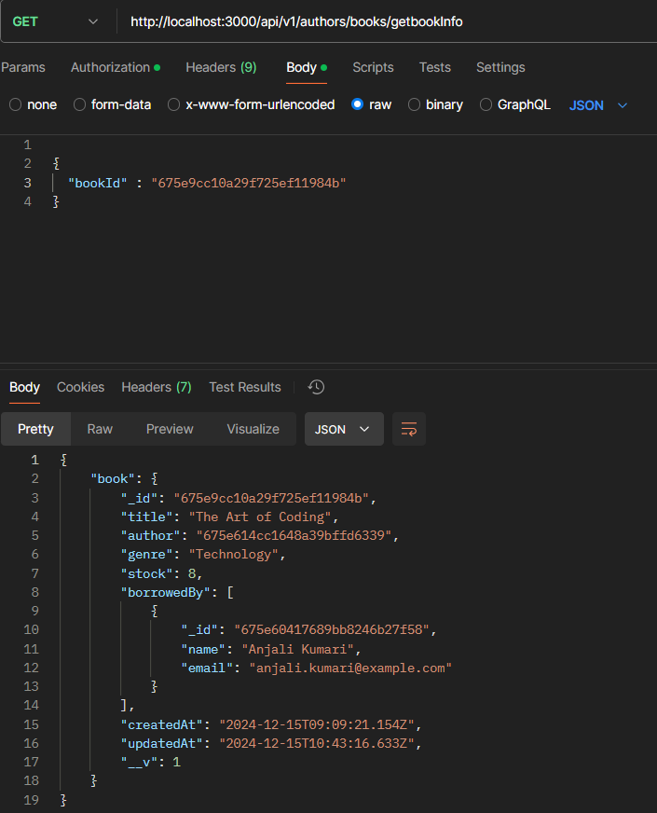

Reader - Seeing the list of borrowed books:

API Endpoint : **GET/api/v1/reader/books**

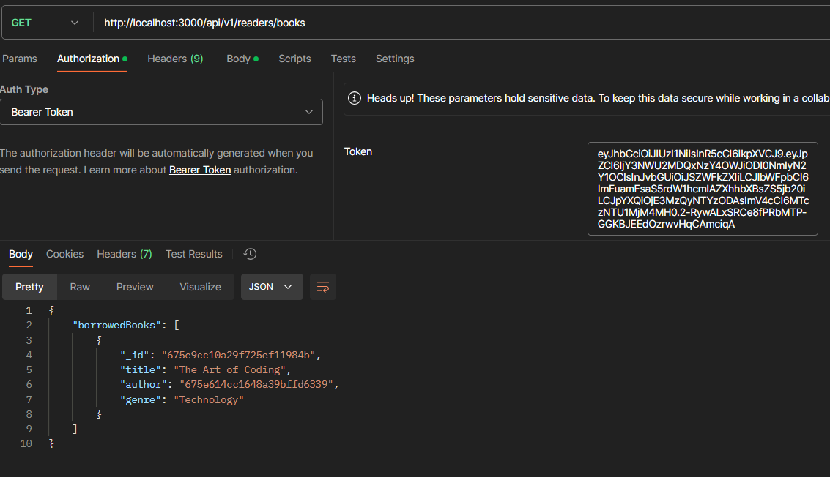

Returning a book back to author Authors POV(observe stock)

API Endpoint: **POST /api/v1/reader/books/return**

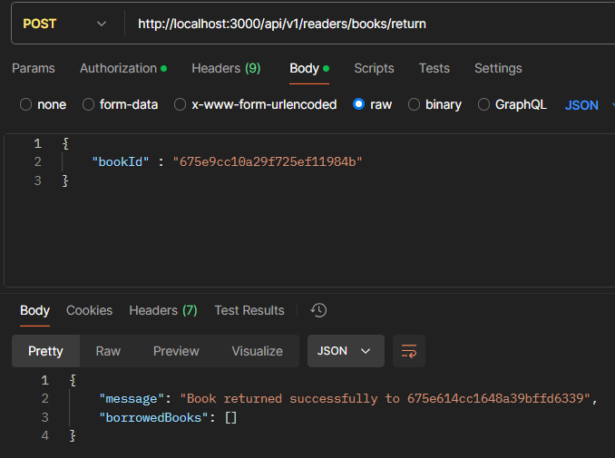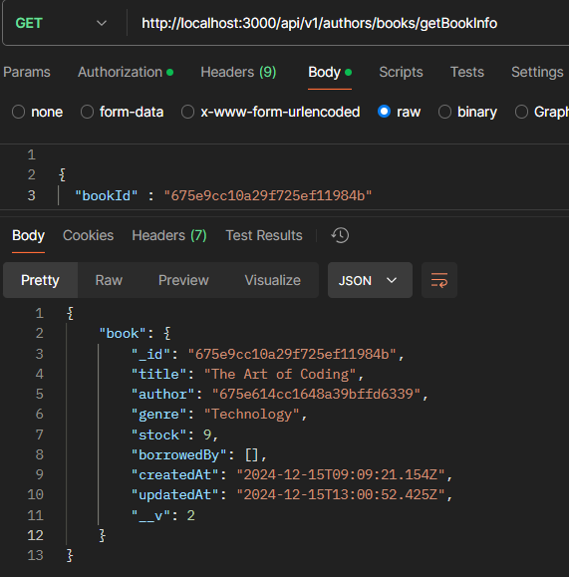

**Public API for fetching books with pagination**

API Endpoint **: GET /api/v1/public/books**

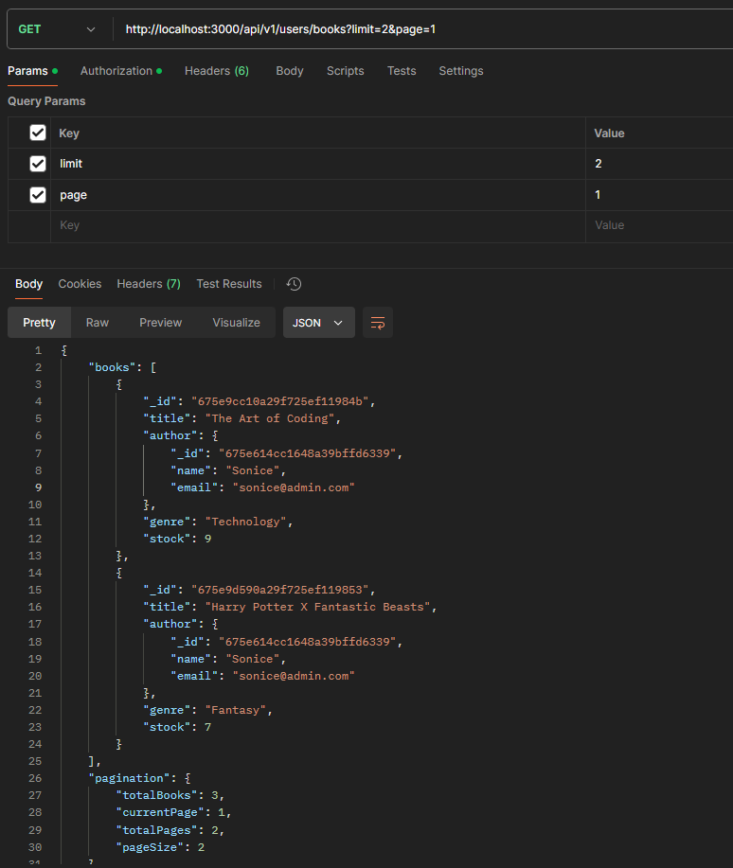

**Public API for fetching books sorted by a search term in title or genre**

API Endpoint **: GET /api/v1/public/books/search**

